Binary & Beyond: Taking Care of Our Bodies – 2SLGBTQI+ Breast & Chest Cancer Screening in Ontario
Addressing a gap in health care information for 2SLGBTQI+ communities
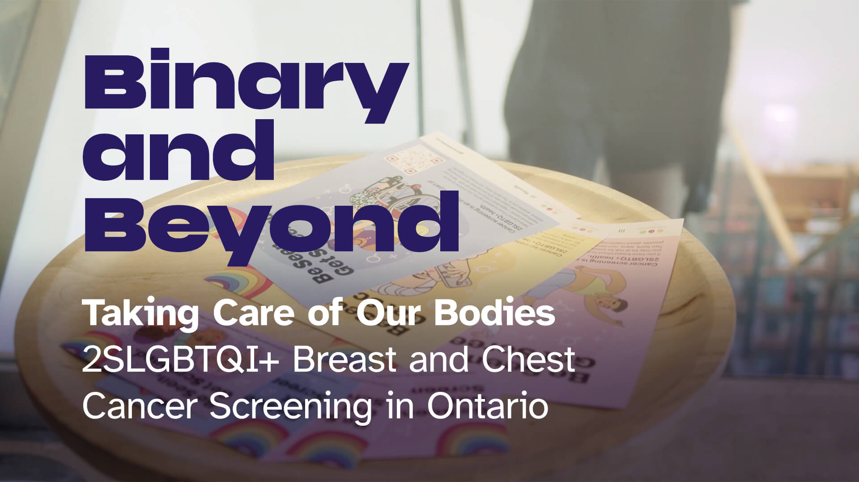
Binary & Beyond is a community-led video produced by the Open Door program at Access Alliance, on behalf of the Mid-West Toronto Ontario Health Team. It includes voices from trans, non-binary, and gender-diverse community members, as they share their experiences, talk about what screening looks like, and discuss why early detection matters with a healthcare professional.
Encouraging 2SLGBTQI+ people aged 40 to 74 in Ontario to get breast and chest cancer screening, the video explores:
- What breast and chest cancer screening means for 2SLGBTQI+ communities
- How mammograms work, and what to expect
- Where to get screened in Ontario
- Resources and supports for inclusive, affirming care
Watch Binary & Beyond here: https://www.youtube.com/watch?v=16-nBYEUwB4
The idea for the video came following a breast/chest screening day organized by Open Door and Kensington Diagnostic Imaging Centre in February 2025. We heard that many 2SLGBTQI+ individuals often don’t realize they should be screened, in part due to a lack of good information about breast/chest cancer screening for this specific community.
Binary & Beyond was created with the goal of improving access to inclusive, culturally competent cancer screening information for trans, non-binary, and gender-diverse people across the province.
The video was filmed in Toronto, with a working group, crew and actors that included representatives from the 2SLGBTQI+ community.
Open Door is an outreach-based initiative of the Mid-West Toronto Ontario Health Team, with Access Alliance as the lead agency. It aims to improve health outcomes for systemically vulnerable populations in our region’s high priority neighborhoods, by increasing access to health care, education and services for individuals and communities.
To learn more about Open Door, please visit https://www.midwesttorontooht.ca/open-door, or contact a member of our team at Info.OpenDoor@AccessAlliance.ca.

